**Step by Step Process**

In Quick sort algorithm, partitioning of the list is performed using following steps...

* **Step 1 -**Consider the first element of the list as **pivot** (i.e., Element at first position in the list).
* **Step 2 -**Define two variables i and j. Set i and j to first and last elements of the list respectively.
* **Step 3 -**Increment i until list[i] > pivot then stop.
* **Step 4 -**Decrement j until list[j] < pivot then stop.
* **Step 5 -**If i < j then exchange list[i] and list[j].
* **Step 6 -**Repeat steps 3,4 & 5 until i > j.
* **Step 7 -**Exchange the pivot element with list[j] element.

Following is the sample code for Quick sort...

**Quick Sort Logic**

//Quick Sort Logic

void quickSort(int list[10],int first,int last){

int pivot,i,j,temp;

if(first < last){

pivot = first;

i = first;

j = last;

while(i < j){

while(list[i] <= list[pivot] && i < last)

i++;

while(list[j] && list[pivot])

j--;

if(i < j){

temp = list[i];

list[i] = list[j];

list[j] = temp;

}

}

temp = list[pivot];

list[pivot] = list[j];

list[j] = temp;

quickSort(list,first,j-1);

quickSort(list,j+1,last);

}

}

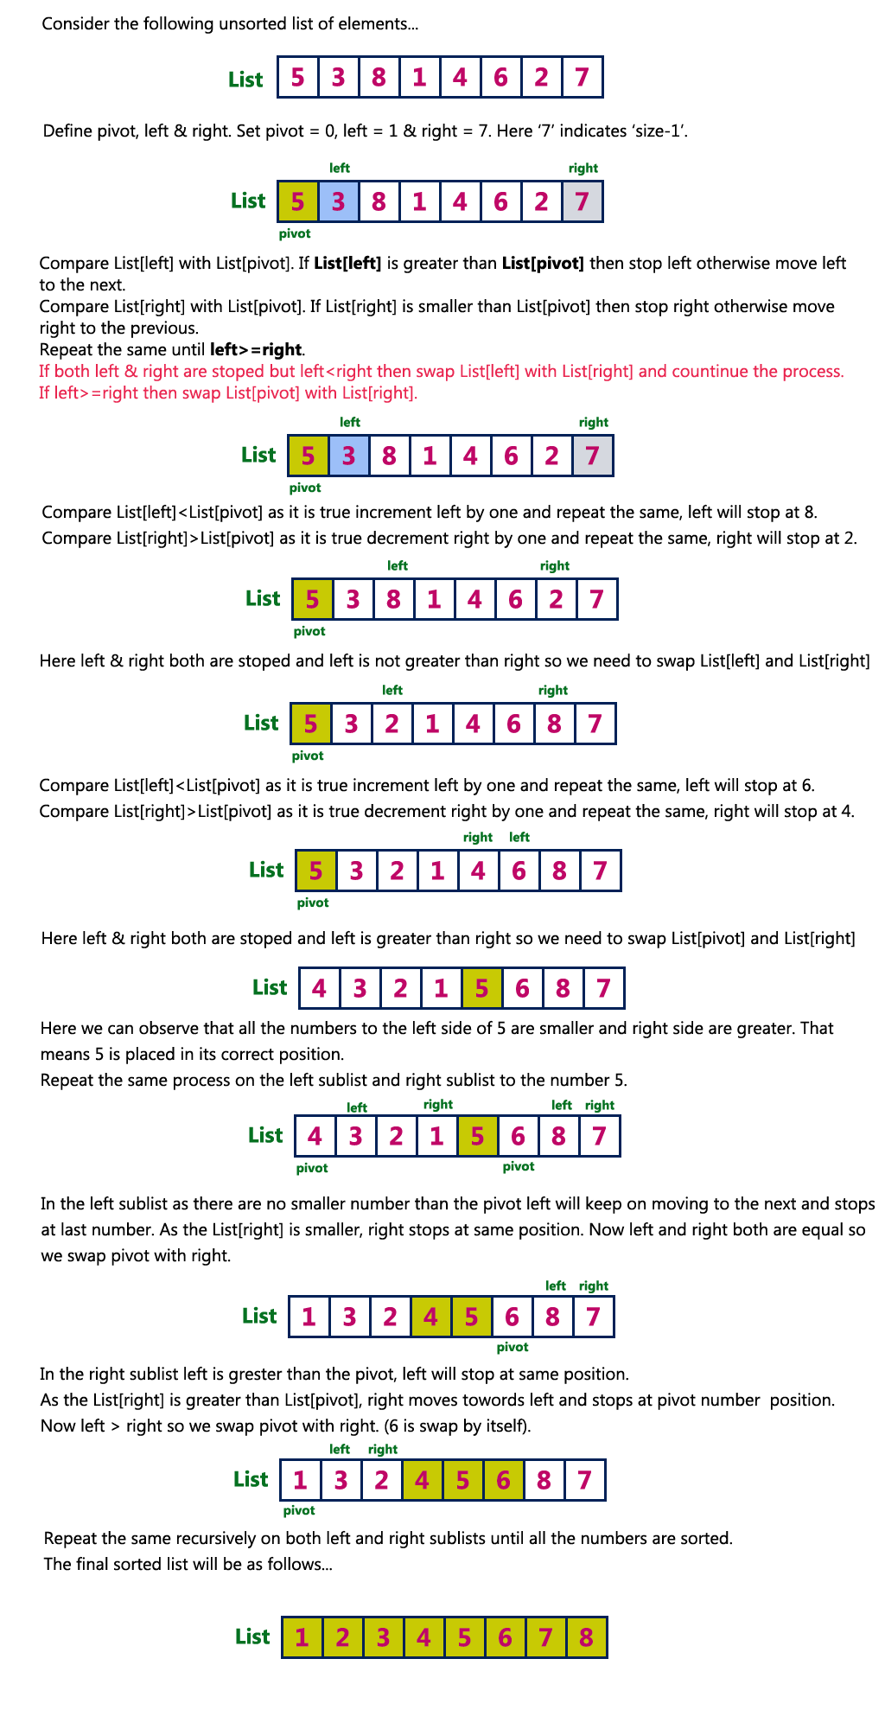

**Complexity of the Quick Sort Algorithm**

To sort an unsorted list with **'n'** number of elements, we need to make **((n-1)+(n-2)+(n-3)+......+1) = (n (n-1))/2** number of comparisions in the worst case. If the list is already sorted, then it requires **'n'** number of comparisions.

**Worst Case : O(n2)**  
**Best Case : O (n log n)**  
**Average Case : O (n log n)**